Progress Report of Mongla Economic Zone

- Progress Report on

- Access Road
- Bridge on Ghona River
- Boundary Wall
- Admin Building
- Water Supply System
- Power Supply With Sub Station

Submitted By:

Md.Ferdous Wahid
Asst.Engineer (Civil)
Bangladesh Economic Zones Development Project (Phase-1)
Bangladesh Economic Zones Authority.

Md.Afzal Hossain
Asst.Engineer (Civil)
Bangladesh Economic Zones Development Project (Phase-1)
Bangladesh Economic Zones Authority. 10,November 2015

- Access Road
Work is being carried out by M/S Mohammad Eunus & Brothers (Pvt) Ltd.

- Status of Work:
- Alignment along the access road from Mongla Port road to Mongla EZ is done by contractor by the direction of consultant.
- Temporary labor shed and storehouse has set up by the contractor for mobilization of building material.
- Contractor has set up a bench mark near to site.
- Contractor has filled a pond in access road near Ghona river and filling is continuing for required height.
- Main work of access road will start after the pile work of bridge.

- Bridge Over Ghona River

Work is being carried out by M/S Mohammad Eunus & Brothers (Pvt) Ltd.

- Status of Work:
- Alignment of bridge across the Ghona River is done by the contractor by the direction of consultant.
- Temporary labor shed and storehouse has set up by the contractor for mobilization of building materials.
- Materials is being mobilized to site about 15 %( Reinforcement, stone chips, sylhet sand and equipment for piling etc.)
- Temporary power supply is obtained from PDB.
- Material test report has submitted to BEZA.
- Palisading work is running for preparation of piling work.
- All supporting equipments for piling work have already mobilized.
- For mix design materials has been send to KUET for testing of M40.
- After getting mix design report and by the approval of consultant pile casting will start.
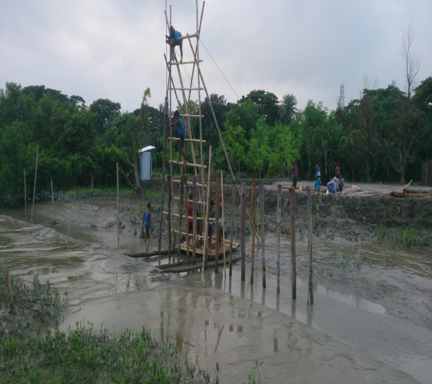

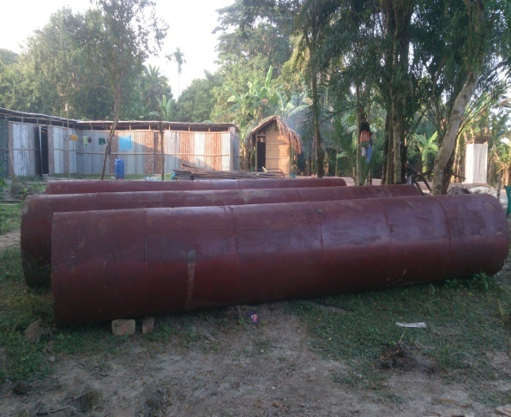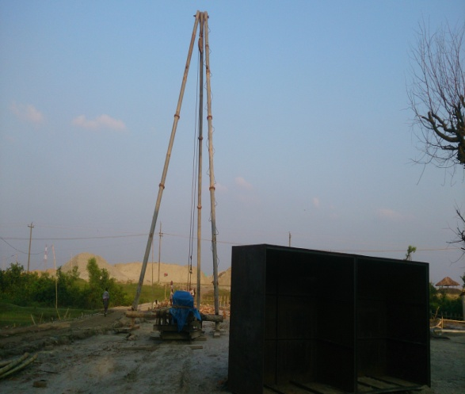
- Boundary Wall

Work is being carried out by M/S SK Idris Ali & M/S Faisal Traders (JV)

- Status of Work:
- Alignment co ordinate for the boundary wall is marked by the contractor by the direction of consultant.
- Temporary bridge has set up over Ghona river to Mongla EZ by the contractor.
- Temporary labor shed and storehouse has set up by the contractor for mobilization of building material.
- Temporary power supply is obtained from REB.
- Contractor has set up a site office.
- Material is being mobilized to site about 25% (Reinforcement, stone chips, sylhet sand and piling equipments etc.)
- The material test report has submitted to BEZA(Reinforcement, stone chips and sylhet sand)
- Total 421 nos pile casted in south side (EPZ side) and west side of EZ area.
- Contractor preparing for pile load test by concern of consultant. And after pile load test plinth beam will start.

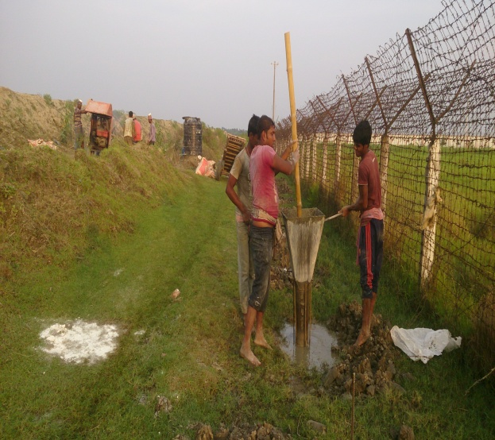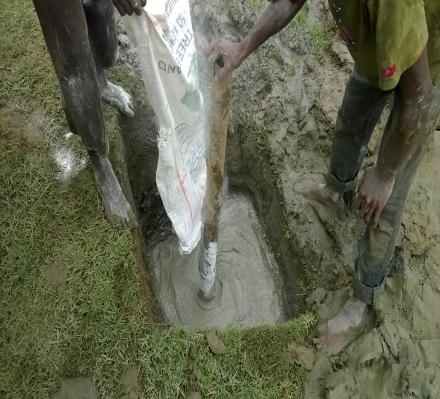
Figure: Piling work of BW

- Admin Building
Work is being carried out by M/S MTSS & ME Consortium.

- Status of Work:
- Location coordinate for the admin building are marked by the contractor by the direction of consultant.
- Temporary bridge has set up over the Ghona River by the contractor.
- Temporary labor shed and storehouse has set up by the contractor for mobilization of building material.
- Contractor has set up a site office.
- Material is being mobilized to site about 15% (Reinforcement, stone chips, sylhet sand, lime ,chemical etc.)
- Temporary power supply is obtained from PDB.
- Contractor has set up a bench mark to site.
- Contractor has started the excavation work and reached at required level.
- Contractor bring the first aid box and safety equipments.
- Material test report has submitted to BEZA.
- Chemical work is done, soil stabilization is done and CC work is done.
- Raft foundation reinforcement work is completed.
- For mix design materials has been send to KUET for testing of M30.
- After getting mix design report and by the approval of consultant casting will start.
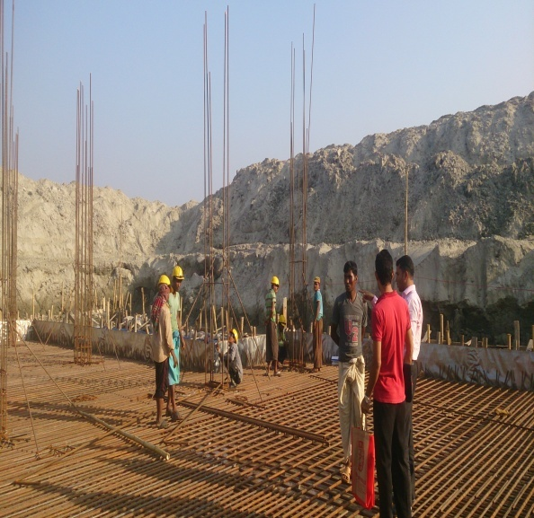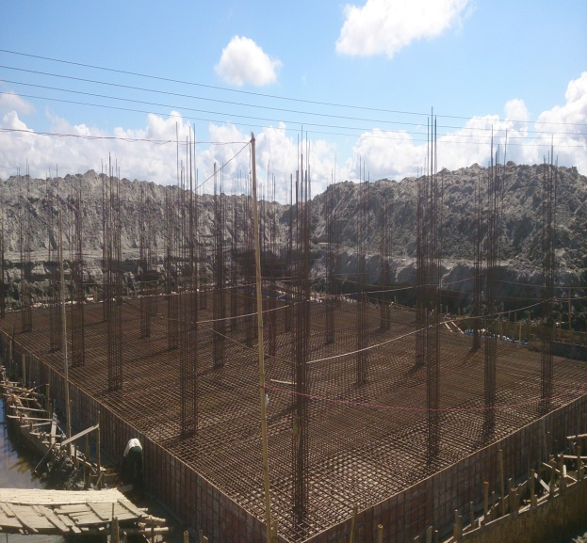
Figure: Reinforcement work Figure: Reinforcement work complete.

- Water Supply System
Work is being carried out by M/S MTSS & ME Consortium.

- Status of Work
- The location of pump station has been selected.
- Water test report has submitted to BEZA.
- Location of reservoir marked by the concern of consultant.
- Excavation work running.

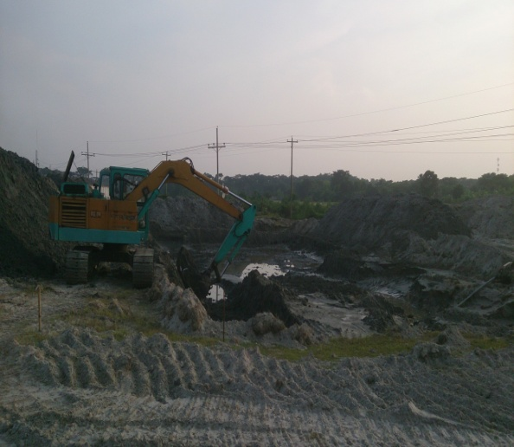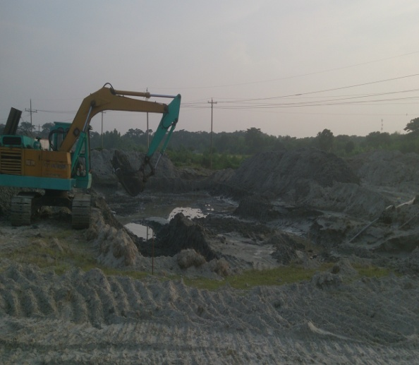
Figure: Excavation work

- Power Supply With Sub Station
Work is being carried out by M/S Energypac Engineering Ltd.

- Status of Work

- Contractor engineer visited the site.
- Mark the four point of substation.
- Soil test done by contractor.

- Observations

- We talk with the GM of REB about the relocation of existing electric line. He said that their paper work is running but not mention the exact date of starting their work.

- We talk with Port Authority (Electric section) about the relocation of existing electric line. They said tender awarded for the relocation and work will start within two or three days.

- We talk with BIWTA about the filling of river side ditch but they are not aware about the filling.

